Students - Join SkillsUSA from your cell phone!
Get started with SkillsUSA by using the link below to enter your Membership information right from your cell phone, computer or tablet:
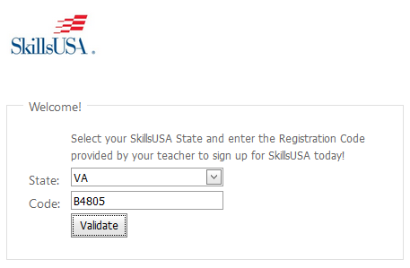
Step 1 – Go to www.skillsusa-register.org/join
Select your State and enter the Registration Code for your Program:
Registration Code: Your advisor will provide the unique code for your class.

Step 2 – After validation, enter your name, date of birth and gender.
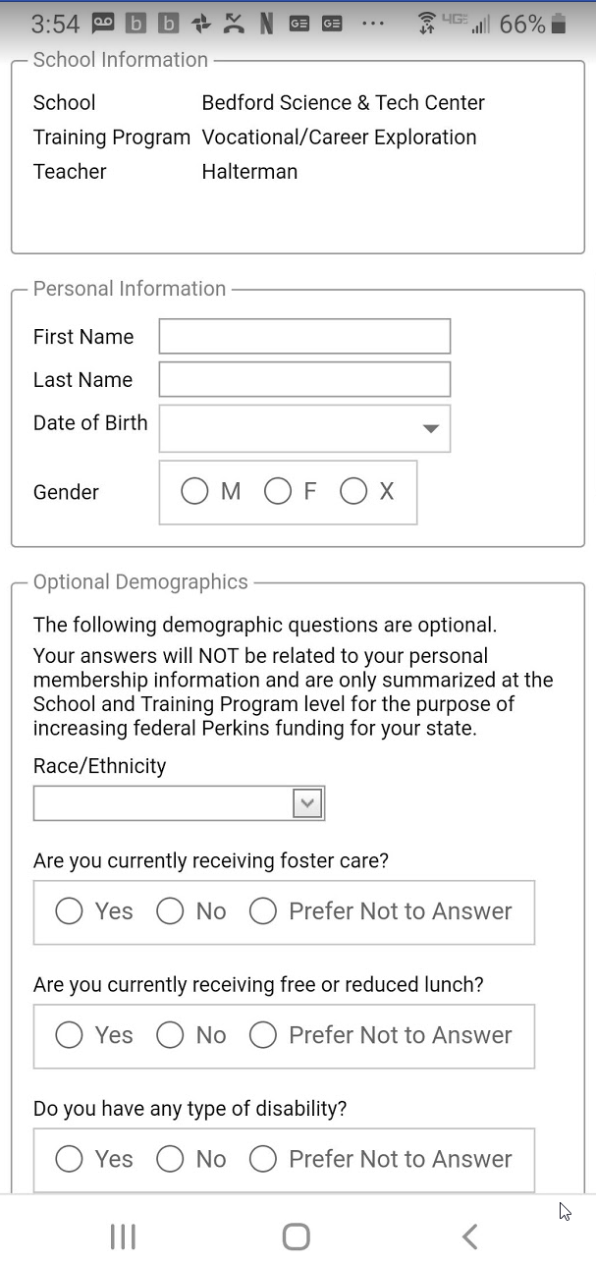
Step 3 – If Student Demographics are enabled for your State, you may optionally provide answers to as many of the demographic questions as you want, then click Register. (Note: these optional demographics are controlled at the State level and useful for federal funding of vocational education. Nothing is required and any answers are stored separately from the individual student information. If the State Director has not enabled Student Demographics, then this section will not be visible at all, and you can just provide your name, date of birth and gender.)

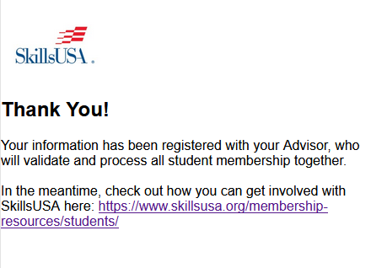
Fill in as much information as you want and click “Register”.

